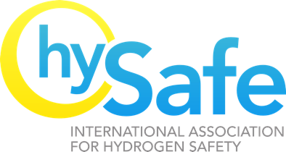

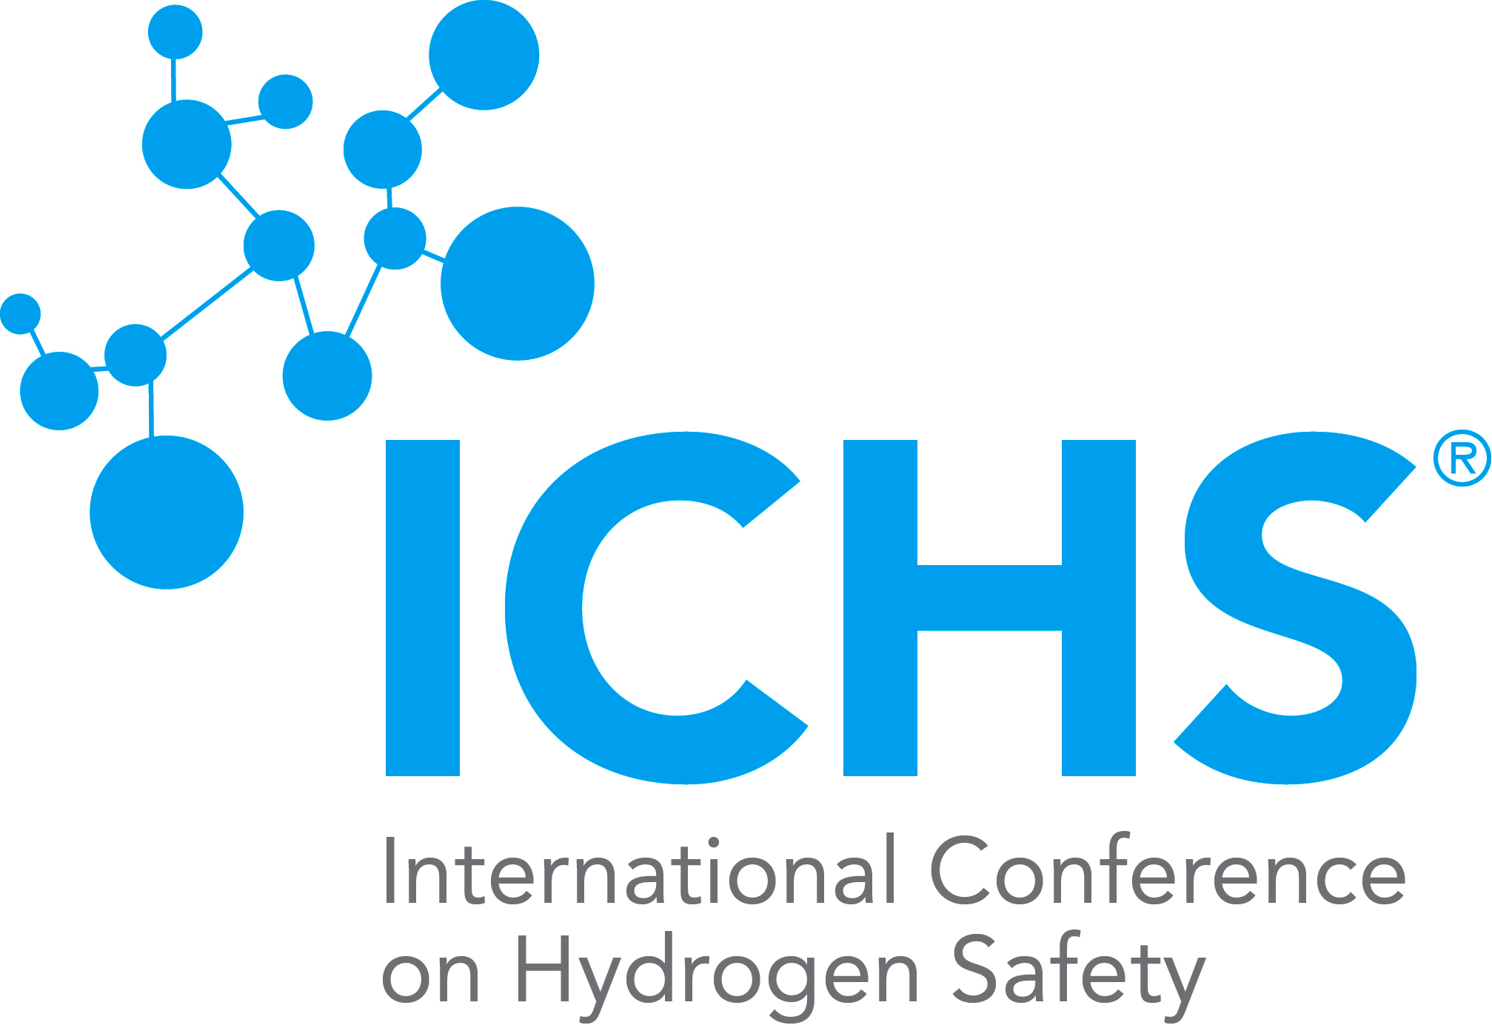

***International Conference on Hydrogen Safety (ICHS2025)***

September 22-26, 2025 – Seoul – Republic of Korea

Invitation Letter

Mr. **XXXX**

**InstitutionXXX**

**AddressXXXX**

**E.MAIL XXXXXX**

Subject: Invitation letter to attend the ICHS2025 Conference in Seoul.

Dear Mr. **xxxxx** (passport no.**xxxxx**, date of issue **xxxxxx**, date of expiry **xxxxxxxxxxx**, nationality **xxx**, Sex **xx**, Date of birth **xxxx**,Place of birth: **xxxx**), on behalf of Organizing Committee of ICHS2025 I invite you to participate at the 11th International Conference on Hydrogen Safety (ICHS2025) to be held in Seoul on 22-26 September 2025.

Your Abstract ID **xxxxx** Titled **xxxxxxx** Authors **xxxxx** has been accepted by the Scientific Committee of ICHS2025 for the participation at the Conference.

In particular no reimbursements for travel and logistics are foreseen from the ICHS2025 organization.

Best Regards.

HongChul Kim from KGS

for the Organizing Committee of ICHS2025

Seoul (South Korea)

Signature of Mr. HongChul Kim from KGS

.

PS This letter is sent via e-mail and digitally signed