PRESLHY-WP/Exp./Inst. | Phenomenon: | Issue addressed/Objective
WP3/E3.1/Pro-Science | Small Scale Multiphase Release | Discharge Coefficients of pressurized or LH2 Releases

Experiment Documentation Sheet
Experimental Set-Up
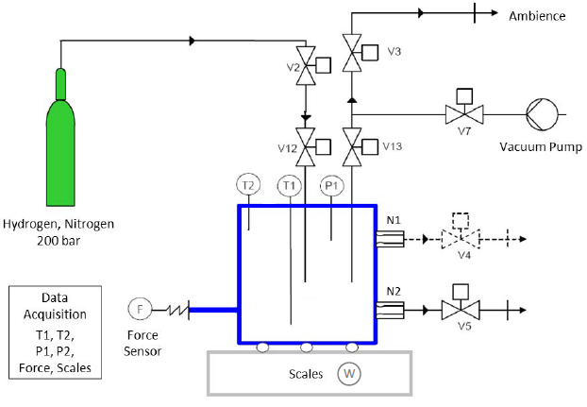
Fig. 1: Sketch of the DisCha-Facility with instrumentation (relevant drawings of vessel and nozzles used can be found in appendix A1).

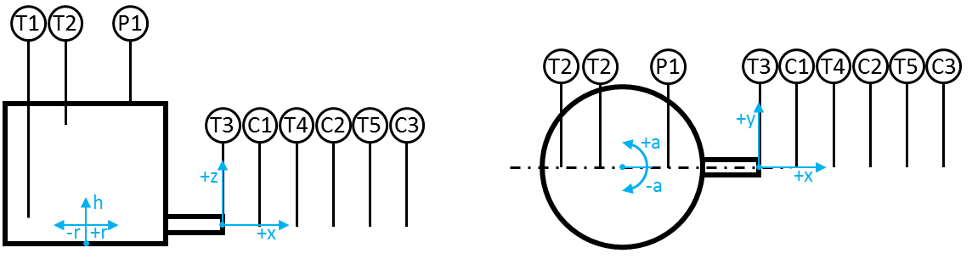
Fig. 2: Sketch of sensor positions inside and outside the DisCha-vessel.

Tab. 1: Sensor positions inside and outside the DisCha-vessel
Sensor | r [mm] | h [mm] | a [°] |  |  | Sensor | x [mm] | y [mm] | z [mm]
T1 | -60 | 30 | 180 |  |  | T3 | 0 | 0 | 0
T2 | -40 | 110 | 180 |  |  | T4 | 100 | 0 | 0
P1 | 40 | 140 | 0 |  |  | T5 | 200 | 0 | 0
 |  |  |  |  |  | C1 | 300 | 0 | 0
 |  |  |  |  |  | C2 | 400 | 0 | 0
 |  |  |  |  |  | C3 | 500 | 0 | 0

PRESLHY-WP/Exp. Number: | Phenomenon: | Issue addressed/Objective
WP3/E3.1 | Small Scale Multiphase Release | Discharge Coefficients of pressurized or LH2 Releases

Data Acquisition System(s)
Settings of the Slow Data Acquisition System (Frequency: 1 Hz)
Only used for pressure record of filling procedure

Settings of the Fast Data Acquisition System:
Frequency: 1 kHz Duration: 32 kSamples Duration: 65.536 s
Pre-Trigger: 30 % Recorded time interval: -19.7 … 45.9 s
Trigger: Channel A5 (Enter Window 0.08 … 4.9 V) OR Channel B1 (enter Window 2 … 9 V)

Tab. 2: Channel-settings of the fast Data Acquisition System
Chan-nel | Sen-sor | Type | Ser.-Nr. | Range | Sensitivity | Filter | Range Data Acq. [V] | Remarks
A1 | P1 | Kulite ITQ-100 | 109 | 0-35 bar | 3.5 bar/V | none | -0.1…4.9
A3 | T1 | NiCr-Ni (d = 0.3) | - |  | 10 K/V | none | -0.1…4.9
A4 | T2 | NiCr-Ni (d = 0.3) | - |  | 10 K/V | none | -0.1…4.9
A5 | F | Althen | 123 | 0-2 kN. | 0.2 kN/V | none | -0.1…9.9
A6 | W | MT-IND 429 | - | 0-150 kg | 15 kg/V | none | -0.1…9.9
A7 | T3 | NiCr-Ni (d = 0.3) | - |  | 10 K/V | none | -0.1…4.9
A8 | C1 | MK FTC300 | 513 | 0-100%H2 | 10%H2/V | none | -0.1…9.9
B1 | T4 | NiCr-Ni (d = 0.3) | - |  | 10 K/V | none | -0.1…4.9
B2 | C2 | MK FTC300 | 514 | 0-100%H2 | 10%H2/V | none | -0.1…9.9
B3 | T5 | NiCr-Ni (d = 0.3) | - |  | 10 K/V | none | -0.1…4.9
B4 | C1 | MK FTC300 | 515 | 0-100%H2 | 10%H2/V | none | -0.1…9.9
B8 | TRG | Trigger |  | TTL | - | none | -1…9

Experimental Conditions
Tab. 3: Initial conditions of the DisCha-Experiments
 |  |  | Ambience |  |  | Vessel
Exp.-Nr. | Date  [DD/MM/YY] | Start Time  [hh/mm/ss] | T_{amb.}  [K] | P_{amb.}  [bar] | RH  [%] | T₀  [K] | P₀*  [bar] | Remarks  (e.g.: H2 or N2, Wind,…)
*relative Pressure

